Adventures with Purpose--
Basel & Lucerne

“Quest for the Crossroads”

Richard Bangs’ Adventures with Purpose—Basel and Lucerne, a new one-hour special from American Public Television, will air on _________ (station) _________________ at (time) _______, (day) __________ (date) _________. Hosted by Richard Bangs who is often called “the father of modern adventure travel,” Basel and Lucerne: Quest for the Cross Roads is the latest documentary in a series of adventure travel, eco-conscience, and historical specials. According to Bangs, “Adventures with Purpose not only quicken the pulse and fire the synapses, they are also journeys of enlightenment and discovery—odysseys that make a difference.”

Adventures with Purpose is produced by Small World Productions of Seattle. The hour-long documentary specials are co-produced by KCTS/Seattle, and Richard Bangs Productions of Marina del Rey, California. KCTS is the presenting station to APT-Exchange, the national distributor.

In Adventures with Purpose: Basel & Lucerne, Richard Bangs is on a journey through a junction where time and place and eternity somehow meet; a small, fierce, rugged place at the meridian of Europe. The Swiss regions of Basel and Lucerne link to one another, and to the world, like hubs to wheels of commerce, enterprise, democracy and freedom.
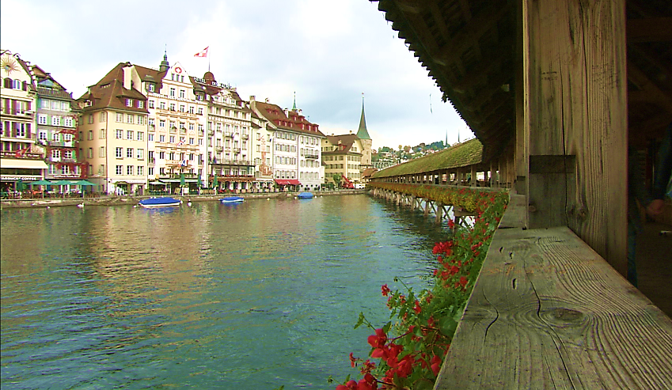
Here is a landscape that could have been created only by earth forces at their most energetic, and we know that the entire welt of mountains that defines the Alps are byproducts of colliding tectonic plates.

But what tectonic shift crunched the landscape of history to create freedom, democracy and wealth at a time when other nations were soaked in bloody conflict? What set the landlocked nation of Switzerland soaring? What made this improbably severe land the Crossroads of Europe? Richard’s quest to understand begins on a modest bridge from the 1200’s across the Schollenen Gorge near the Gotthard Pass. Building the Devil’s Bridge was so difficult the Devil had to help. In return he demanded to own the first soul to cross it. The workers tricked the Devil and drove a goat over bridge first.

That goat marked the beginning of a new era. According to Richard, “Romans had long trudged across this cardinal pass, but the sonic architecture of the Devil’s Bridge truly opened the way for travelers, smugglers and traders from the Mediterranean to the North Sea. And trade meant taxes. Suddenly this highland matrix of autonomous sleepy villages saw the flowers of wealth spring in its stony places.”

History shows that what followed was the building of a bridge of faith, spanning to a place they could not see: democracy and nationhood. So this is the story of people both profiting from and defending their strategic location; a story of war and peace, and freedom cropping from the collision of the two. It’s the narrative of Switzerland in general, and Central Switzerland in particular. And Richard’s Quest for the Crossroads takes him to the Lucerne and Basel regions of Switzerland.
Adventures with Purpose--
Basel & Lucerne

Switzerland is the most mountainous country in Europe, an icy ring of teeth that bites off Italy from the rest of the continent. So, how did this daunting and deadly barrier become the handshake to the opposite seas of Europe, the great link for goods, ideas, medicines and people? Richard’s quest is to find out by following the ancient trade routes from the Gotthard pass, down into Central Switzerland, along Lake Lucerne and to the port city of Basel.

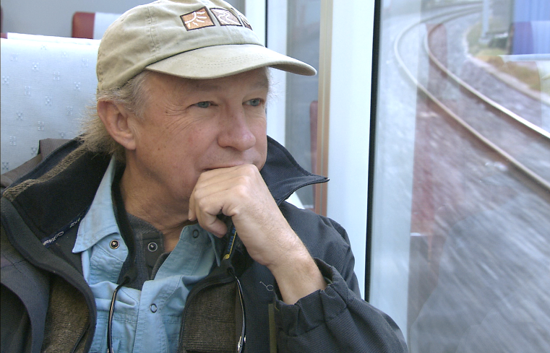
Host and co-executive producer, Richard Bangs is a pioneer in travel that makes a difference, travel with a purpose. He has spent more than 30 years as an explorer and communicator, and along the way led first descents of 35 rivers around the globe, including the Yangtze in China and the Zambezi in Southern Africa. Richard has published more than 1000 magazine articles, 18 books, a score of documentaries and CD-ROMs; and has lectured at the Smithsonian, the National Geographic Society, the Explorers Club and many other notable venues. He writes feature articles for the Huffington Post. His latest books include Adventures with Purpose, Quest for Kaitiakitanga, Quest for the Sublime and Quest for the Kasbah, companion books for episodes in the television series.

Richard’s books and DVDs of Adventures with Purpose—Basel and Lucerne: Quest for the Cross Roads are available from Small World Productions. Each DVD contains the complete show and more than an hour of value-added bonuses including never-before-seen footage, and behind-the-scenes glimpses. DVDs are $24.95 each plus shipping. Richard’s Adventures with Purpose books are $16.95 each plus shipping. Books include essays by Richard on a number of destinations. The book and DVD together are $35.95 plus shipping. Viewers may order online at www.AdventuresWithPurpose.TV or call the order desk at 800.866.7425.

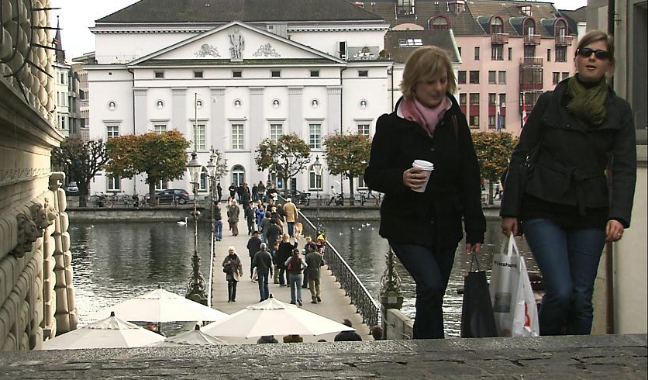
Adventures with Purpose—Lucerne and Basel: Quest for the Cross Roads will be up-linked on APT’s HD satellite transponder. HD and standard definition “letterboxed” versions of the documentary will air on hundreds of public TV stations nationwide. Digital audio is transmitted in stereo.

Adventures with Purpose--
Basel & Lucerne

American Public Television (APT) has been a leading distributor of high-quality, top-rated programming to America’s public television stations since 1961. Since 2004, APT has distributed approximately half of the top 100 highest-rated public television titles. Among its 300 new program titles per year are prominent documentaries, news and current affairs programs, dramatic series, how-to programs, children’s series and classic movies, including For Love of Liberty: The Story of America’s Black Patriots, A Ripple of Hope, Rick Steves' Europe, Newsline, Globe Trekker, Simply Ming, Travelscope, America's Test Kitchen From Cook’s Illustrated, Lidia's Italy, P. Allen Smith's Garden Home, Murdoch Mysteries, Doc Martin, Rosemary & Thyme, The Rat Pack: Live and Swingin’, Johnny Mathis: Wonderful, Wonderful! and John Denver: The Wildlife Concert. APT also licenses programs internationally through its APT Worldwide service. In 2006, APT launched and nationally distributed Create® – the TV channel featuring the best of public television's lifestyle programming. APT is also a partner in the WORLD™ channel expansion project including its web presence at WORLDcompass.org. For more information about APT’s programs and services, visit APTonline.org. For more information on Create, visit CreateTV.com.

Richard Bangs’ Adventures with Purpose
Basel and Lucerne: Quest for the Cross Roads

Co-produced by
| Small World Productions | KCTS/ Seattle |Richard Bangs Productions |

Small World Productions | 140 Lakeside Avenue | Suite 200 | Seattle WA 98122 |
|www.AdventuresWithPurpose.TV | 206 329 7167 | johngivens@travelsmallworld.com |

